## ****Slide 1: Title Slide****

Title: Smart Logistics Optimization using Data Analytics

Subtitle: End-to-End Analytics Case Study

Harisha | Data Analyst

Tools used: MySQL | Python | Statistics | Power BI

## Slide 2: ****Case Study Overview****

A mid-sized logistics company has been struggling with frequent shipment delays, high waiting times at warehouses, and uneven asset utilization across its fleet.These operational inefficiencies have started to affect customer satisfaction and retention, while putting a significant portion of the company’s revenue at risk.

The management team seeks a data-driven analysis to answer critical business questions and make informed decisions. The ultimate goal is to understand delay patterns,quantify financial and operational impact, and identify actionable strategies to improve fleet performance, reduce delays, and protect revenue.

### 1. Problem Statement

A logistics company is struggling with **frequent shipment delays, high waiting times, under utilization of assets.** These inefficiencies are leading to increased costs, reduced customer satisfaction, and poor operational visibility.

The company seeks a **data-driven solution** to optimize operations, reduce delays, and improve asset utilization.

### 2. Client Requirements

The logistics company wants:

**Shipment Performance Analysis**

Identify the factors contributing to **logistics delays** (traffic, weather, inventory levels, waiting time).

Measure **on-time delivery rates** and delay patterns.

Estimate what portion of company revenue is at risk due to these delays.

**Operational Patterns & Planning**

Analyze shipment delays by daily,weekly,monthly to identify peak bottleneck hours

Do shipments during weekdays differ in delays compared to weekends

**Asset Utilization Insights**

Track Average Utilization by fleet utilization (e.g., trucks, warehouses).

Highlight **under utilized vs. Over utilized assets.**

**Customer & Revenue Impact**

Do frequent buyers experience significantly more delays than occasional buyers?

which customer groups (based on purchase frequency/segment) are most affected by delays.

Check whether weather conditions (temperature, humidity) or other environmental variables correlate with delays

### 3. Tools & Methodology

workflow of Project :

· **MySQL**: Store and query logistics data, generate KPIs (shipment delays, asset utilization, forecast accuracy).

· **Python (Pandas, Scikit-learn, Statsmodels, Matplotlib/Seaborn)**:

Data cleaning and pre processing.

Exploratory Data Analysis (EDA).

Statistical testing (impact of traffic/weather on delays).

· **Statistics**: Hypothesis testing and correlation analysis.

· **Power BI**: Build interactive dashboards for real-time business insights.

**Dataset Description**

**Timestamp** → Shipment date & time (trend analysis)

**Asset_ID** → Truck/vehicle identifier (utilization tracking)

**Latitude & Longitude** → GPS location (route optimization)

**Inventory_Level** → Actual stock carried (supply monitoring)

**Shipment_Status** → Delivery stage (tracking progress)

**Traffic_Status** → Road condition (impact on delays)

**Waiting_Time** → Idle time at checkpoints (delay factor)

**Asset_Utilization** → % truck load used (efficiency measure)

**Demand_Forecast** → Predicted demand (forecast accuracy)

**Logistics_Delay** → 0 = On time, 1 = Delayed (target variable)

**Data Cleaning :**

After understanding dataset next we need to clean the data.

1. I started checking the dataset information and duplicated records
2. Statistical information and checking for null values
3. also converted Timestamp data from Object datatype to datetime datatype

**EDA :**

**Business Questions :**

**Shipment Performance Analysis**

1. Measure **on-time delivery rates** and delay patterns.

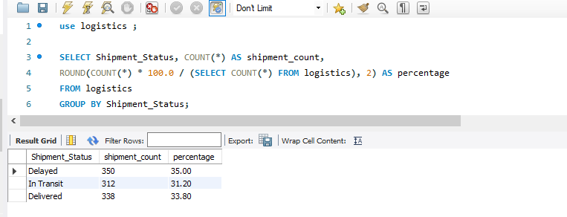

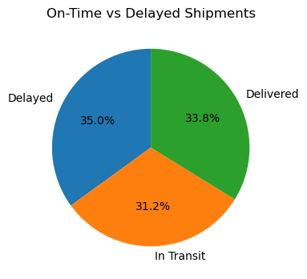

2.Estimate what portion of company revenue is at risk due to these delays

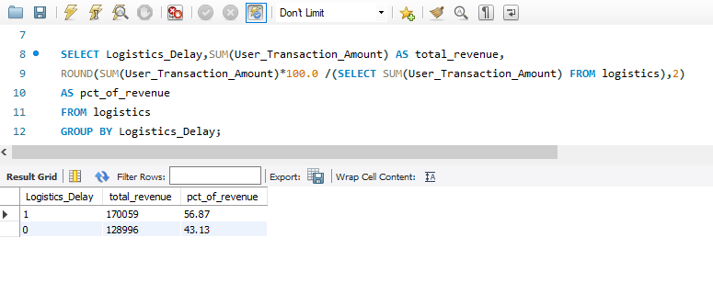

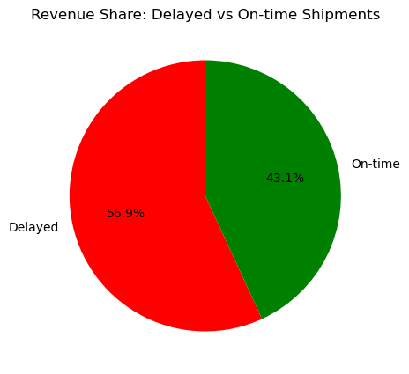

1. **Root Cause Analysis for Delays :**
2. Identify the Main reasons for shipment delays (traffic, waiting times, operational bottlenecks).

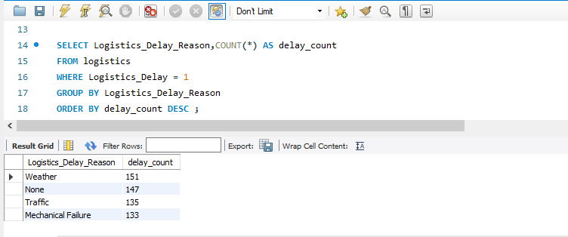

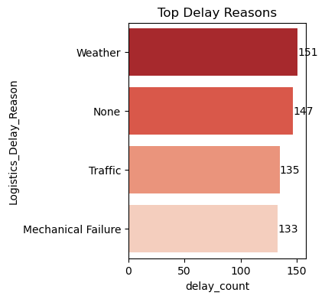

4. Does traffic conditions significantly impact delays.

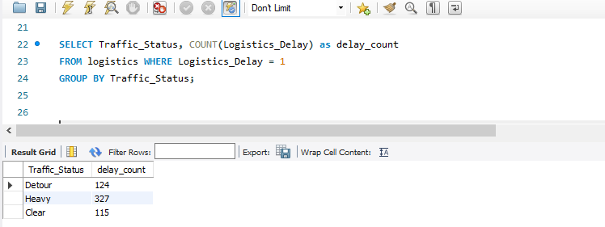

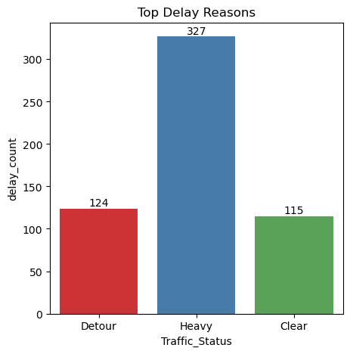

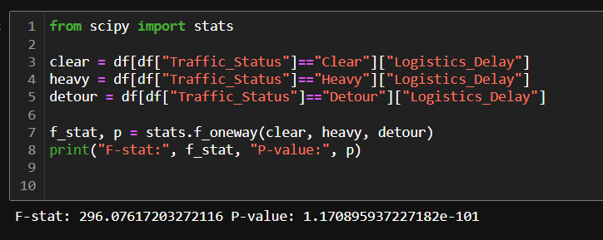

1. Does waiting time affect likelihood of delays?.

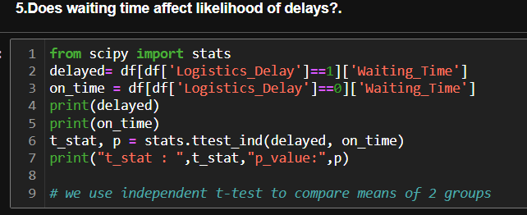

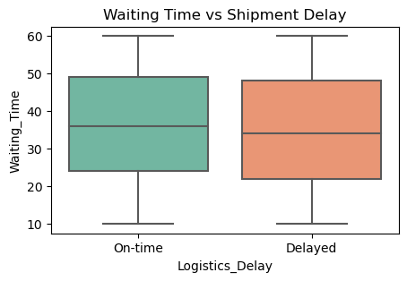

1. **Operational Patterns & Planning**

6.Analyze shipment delays by time of day to identify peak bottleneck hours

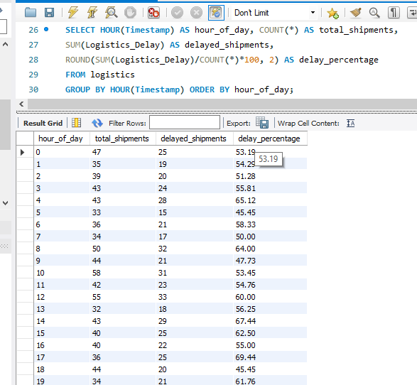

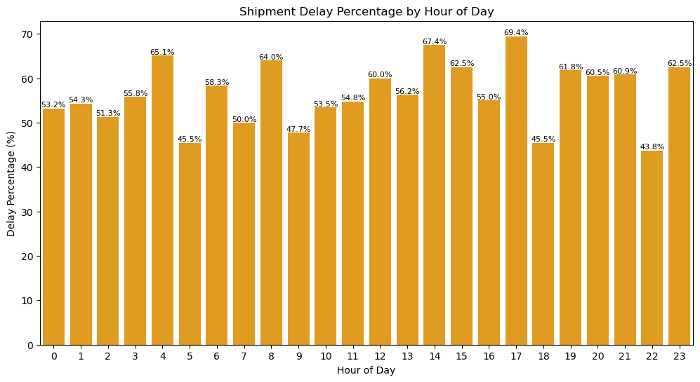

7.Assess day-of-week delay patterns (are certain weekdays/weekends worse?)

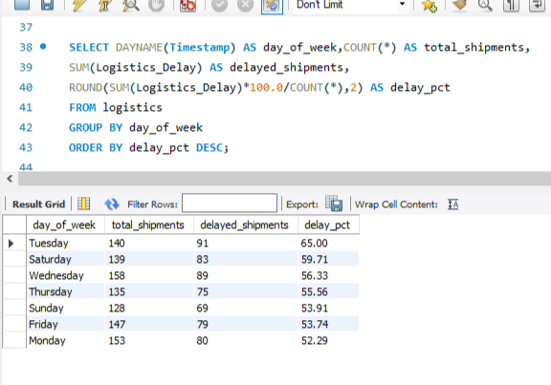

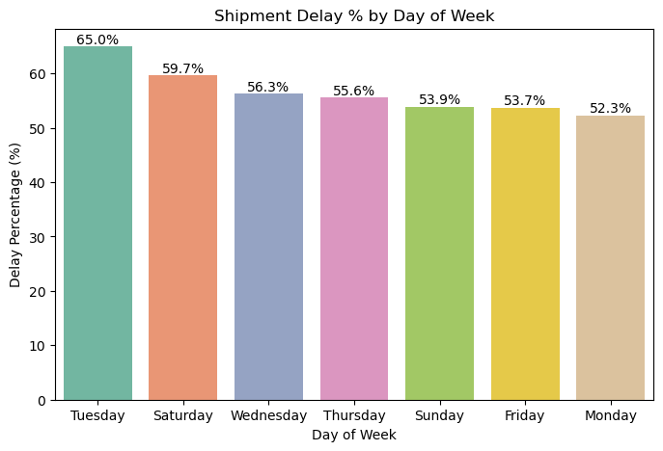

1. Do shipments during weekdays differ in delays compared to weekends?

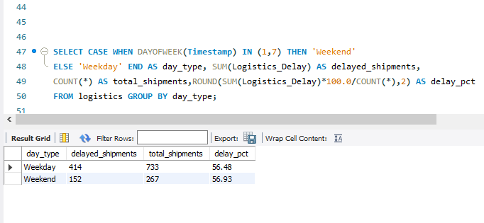

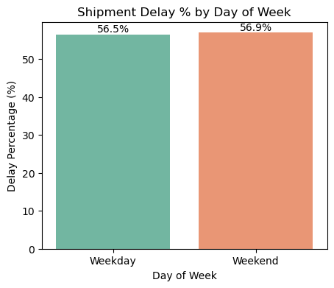

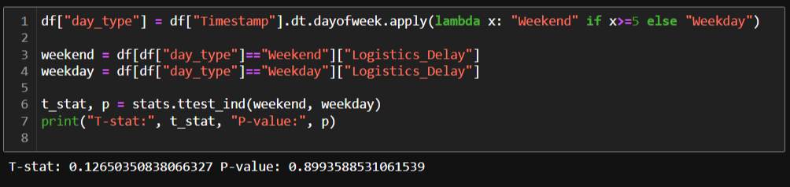

1. Do shipment delays follow monthly or seasonal patterns?

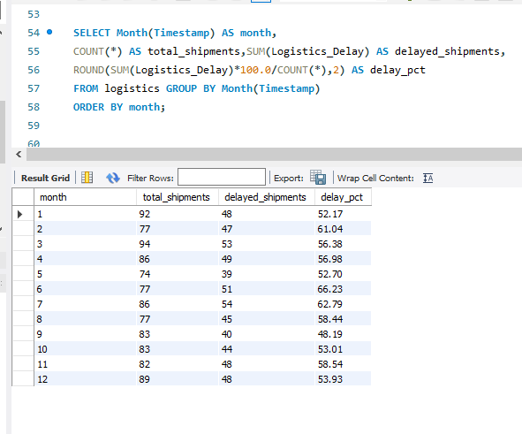

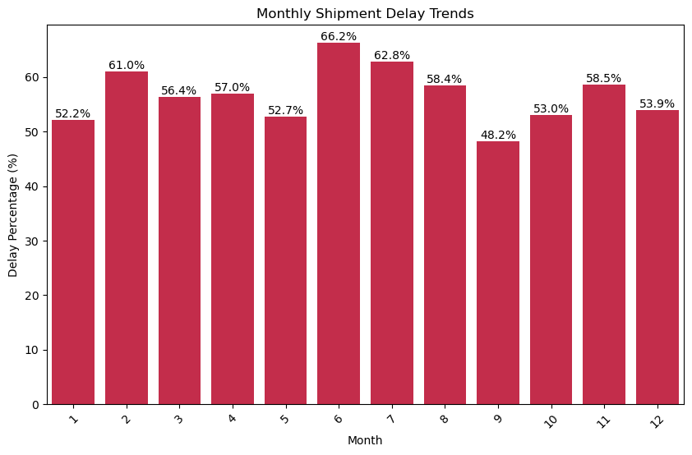

1. **Asset & Fleet Utilization :**
2. Calculate the average utilization of each truck/asset.

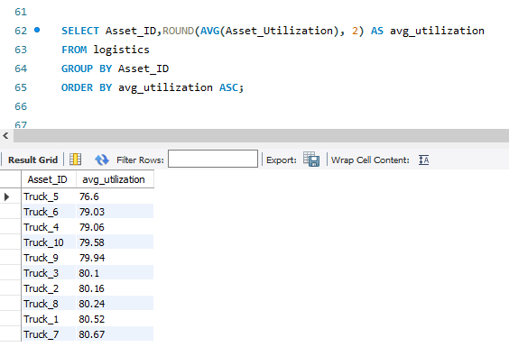

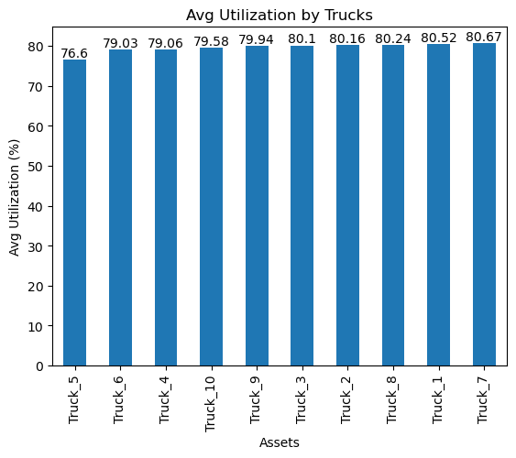

11.Detect which assets are under-utilized (<50%) or over-utilized (>90%), leading to inefficiencies.

1. **Customer & Revenue Impact :**

12.Determine which customer groups (based on purchase frequency/segment) are most affected by delays.

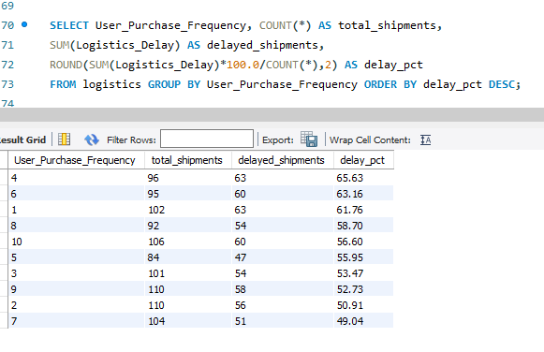

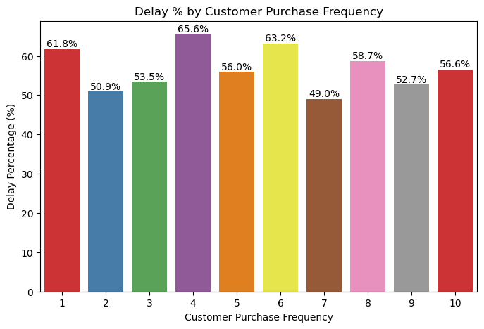

13.Do frequent buyers experience significantly more delays than occasional buyers?

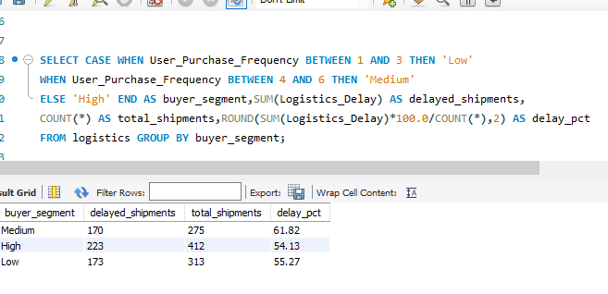

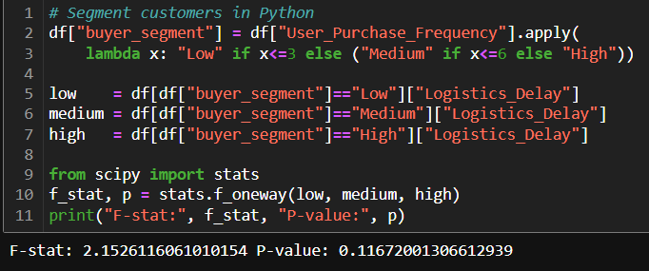

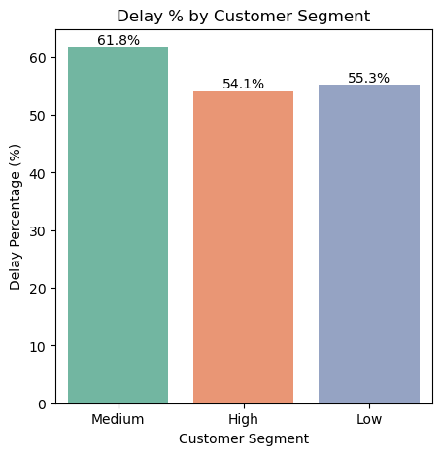

1. Examine whether weather conditions (temperature, humidity) or other environmental variables correlate with delays

